Wimshurst Static Generator

<https://github.com/penoel/Wimshurst>

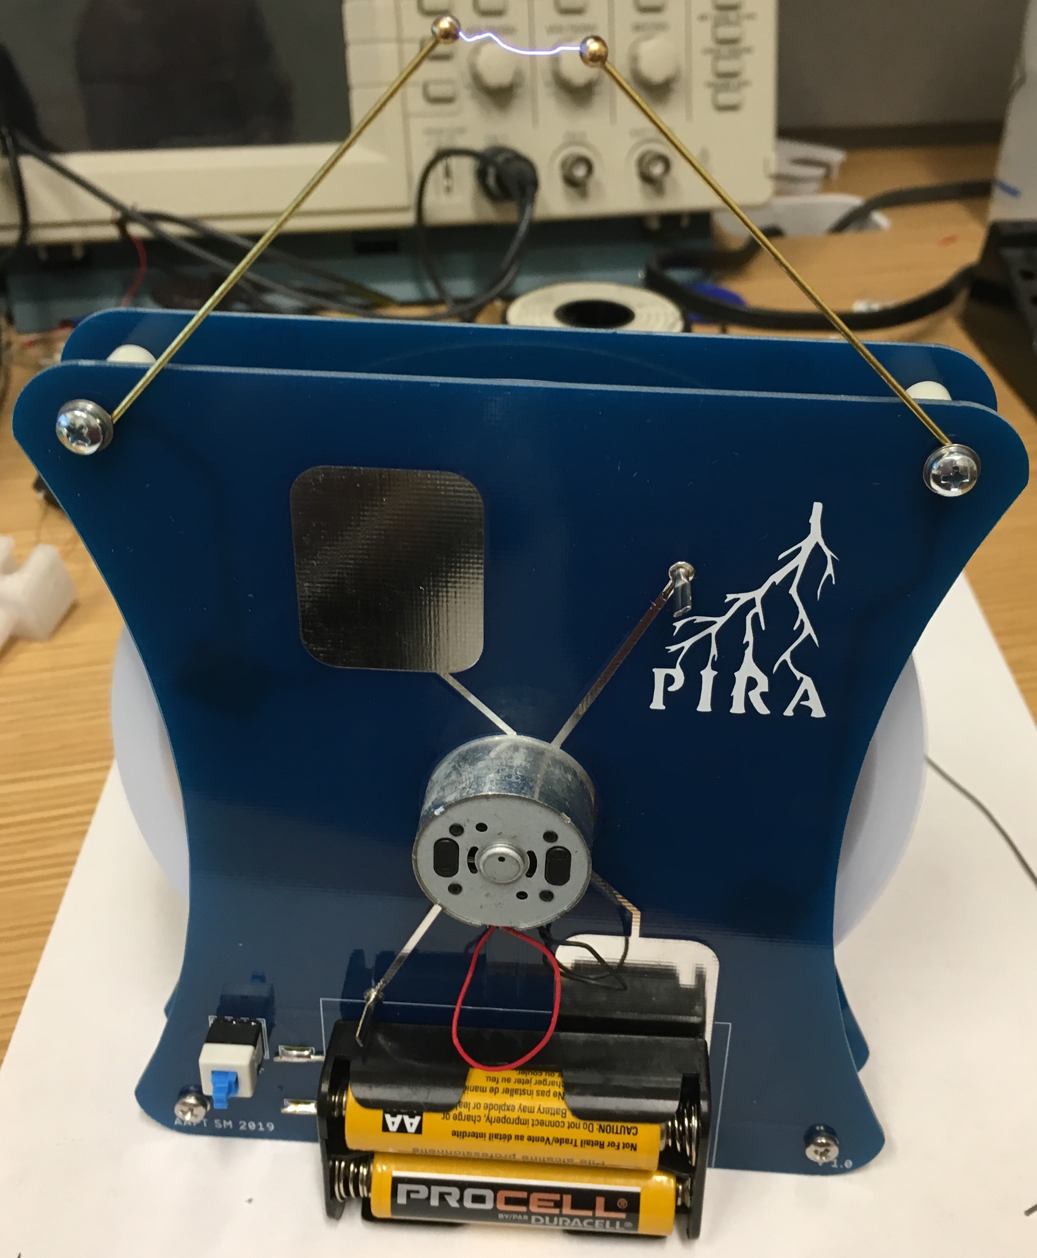

The Wimshurst machine is a high voltage generator that relies on electrostatic induction. It comprises two counter-rotating insulated disks with small conductive unconnected pie slices, two sets of charge collection combs, and two sets of brushes (1 set/disk and sets are 90° separated relative to each other). As a disk section rotates past the brush, it induces an opposite charge on the other disk that in turn causes the other brush on the same side to have an opposite charge. As these charged sections pass by the combs, charge is pulled off and stored. The charge is stored in 2 large capacitors integrated into the front and back PCBs (cap specs-length: 30.0mm, width: 24.5mm, corner radius: 5mm, separation: 1.6mm, relative permeability: 4.4). The capacitors are then discharged through an adjustable spark gap. The distance between the two electrodes that comprise the spark gap will correlate to the voltage of the spark (3000V/mm in air). As mentioned above, this device uses electrostatic induction, meaning it will not work if no charge is present on the disk. The disk will almost always have a small charge, so a charge does not need to be added to the disks prior to starting it.

In this project you will be constructing your own inexpensive Wimshurst machine. This will allow you to create high voltage sparks and do some fun electrostatic demonstrations.

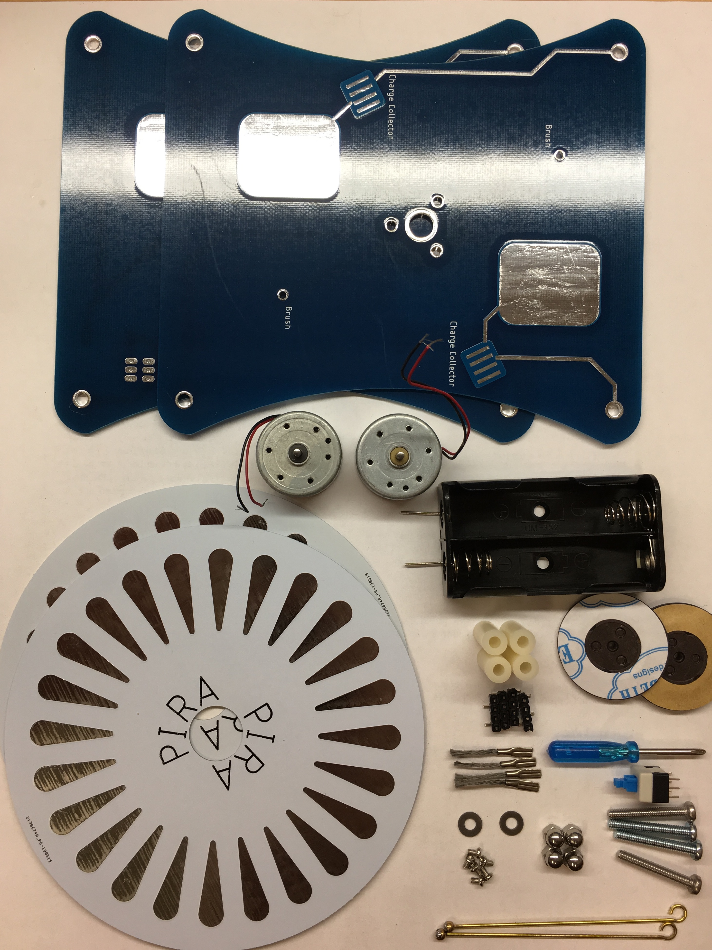

The Wimshurst kit contains the following components:

* 1 – Front PCB
* 1 – Back PCB
* 2 – Disk PCBs
* 2 – Motors
* 4 – M3 Dome Nuts
* 2 – M3 Washers
* 2 – Hubs
* 1 – Button
* 2 – Electrodes
* 1 – Battery Holder
* 1 – Zip tie
* 6 – M1.7x3mm Screws
* 4 – M3x22mm Screws
* 4 – Spacers
* 4 – Brushes
* 4 – Combs
* 1 – Screwdriver
* 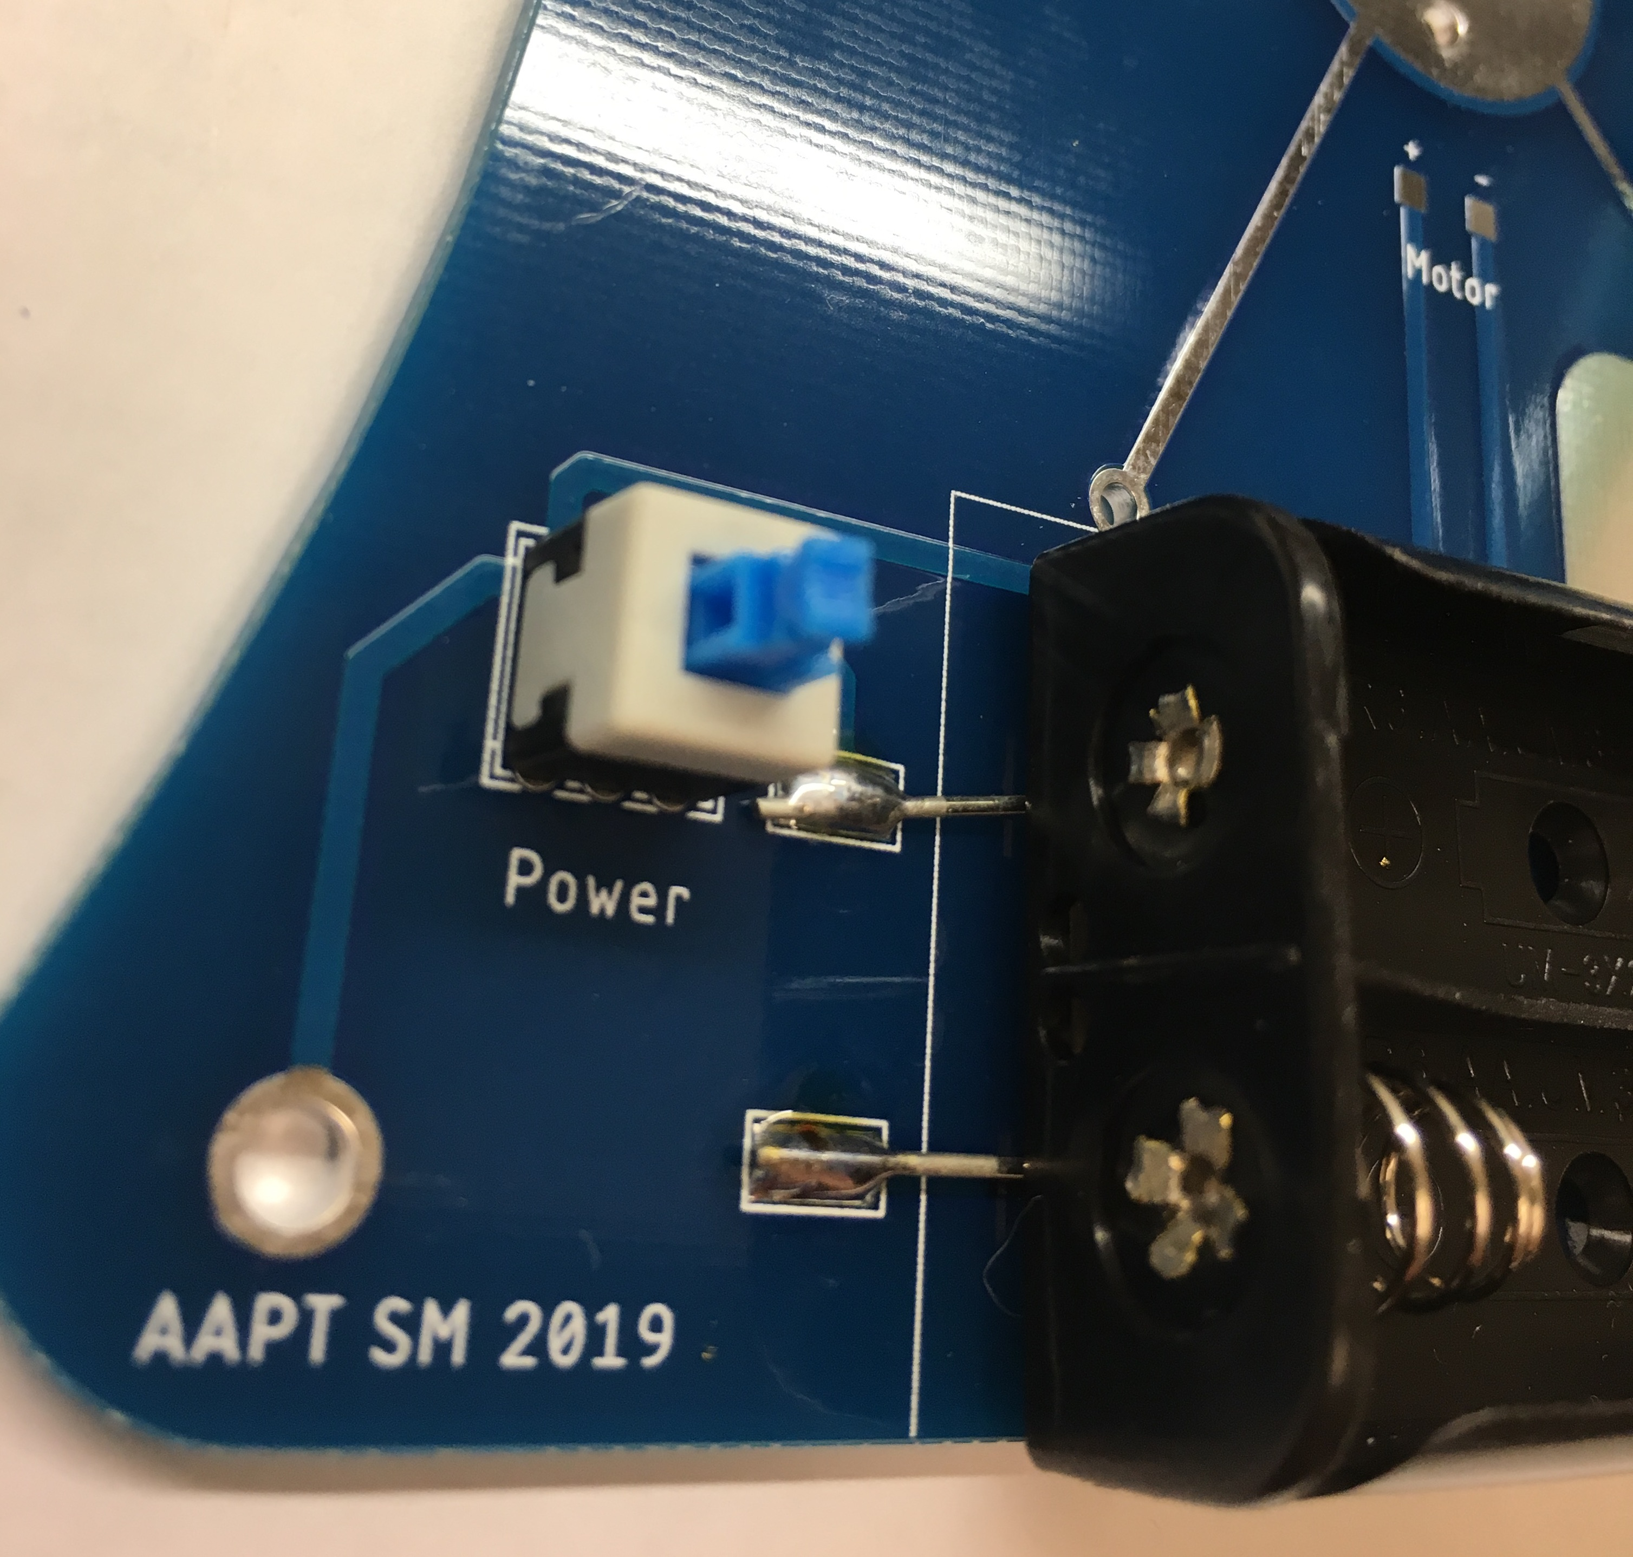Remove the paper from the foam tape on the battery holder, then place it on the front PCB.
* Make sure the solder lugs of the battery holder are over the pads and solder it in place.
* Install the button and flip the board over. Then solder it.
* 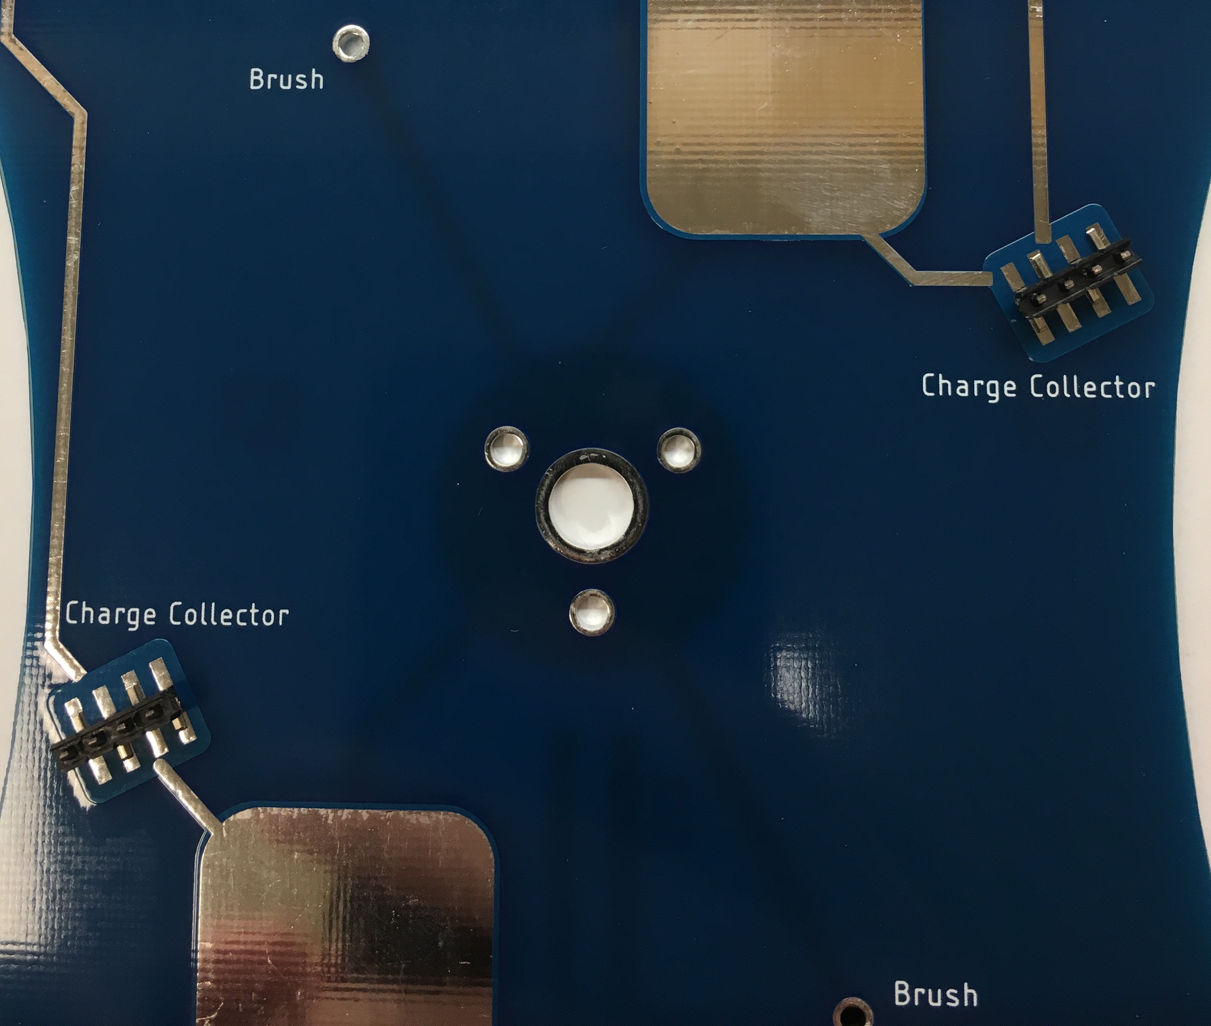With the board flipped, place the charge collecting combs on the pads and solder them in place.
* Repeat for the back board.
* 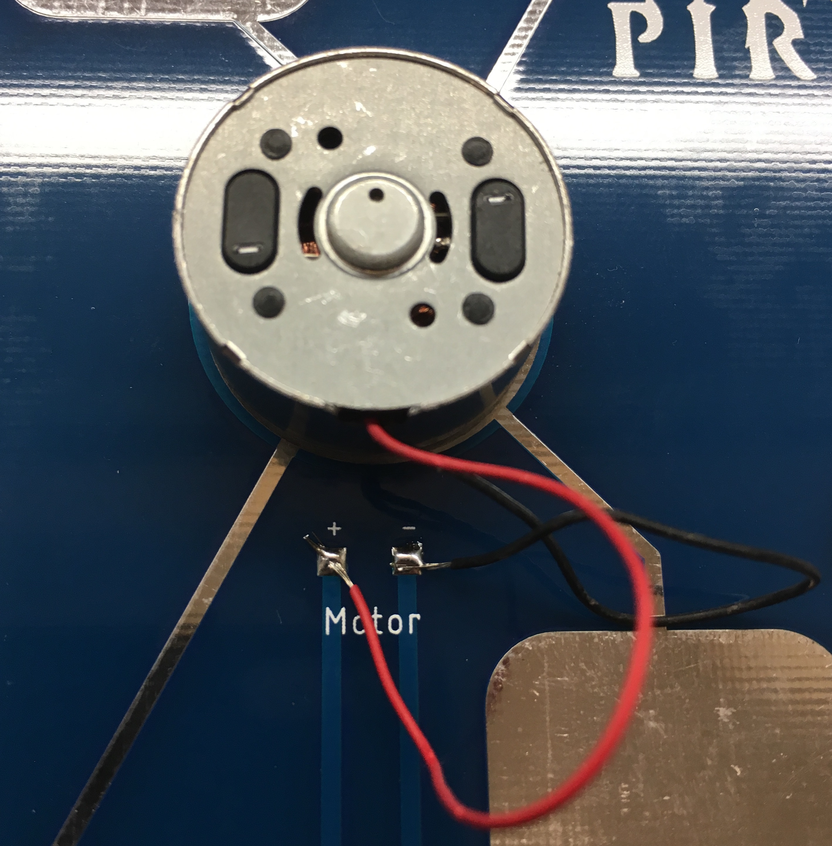Install the motors making sure that the wires are pointing at the motor pads on the PCB. Screw the motors in with the small (M1.7) screws.
* Solder the motor wires to the pads noting the polarity Red = + Black = - (remember they have to counter-rotate).
* 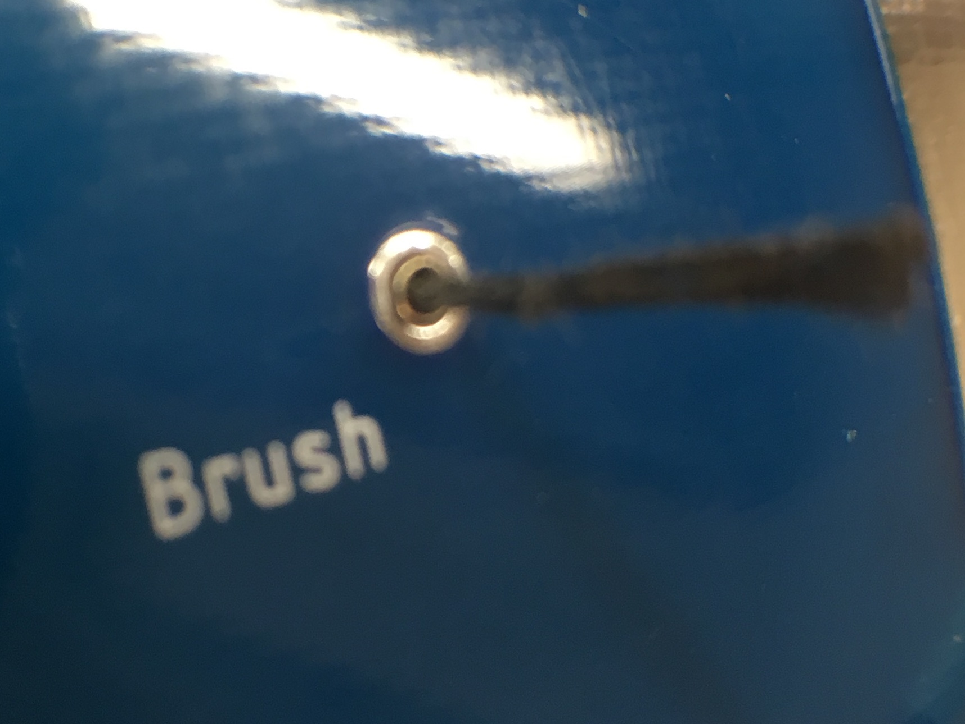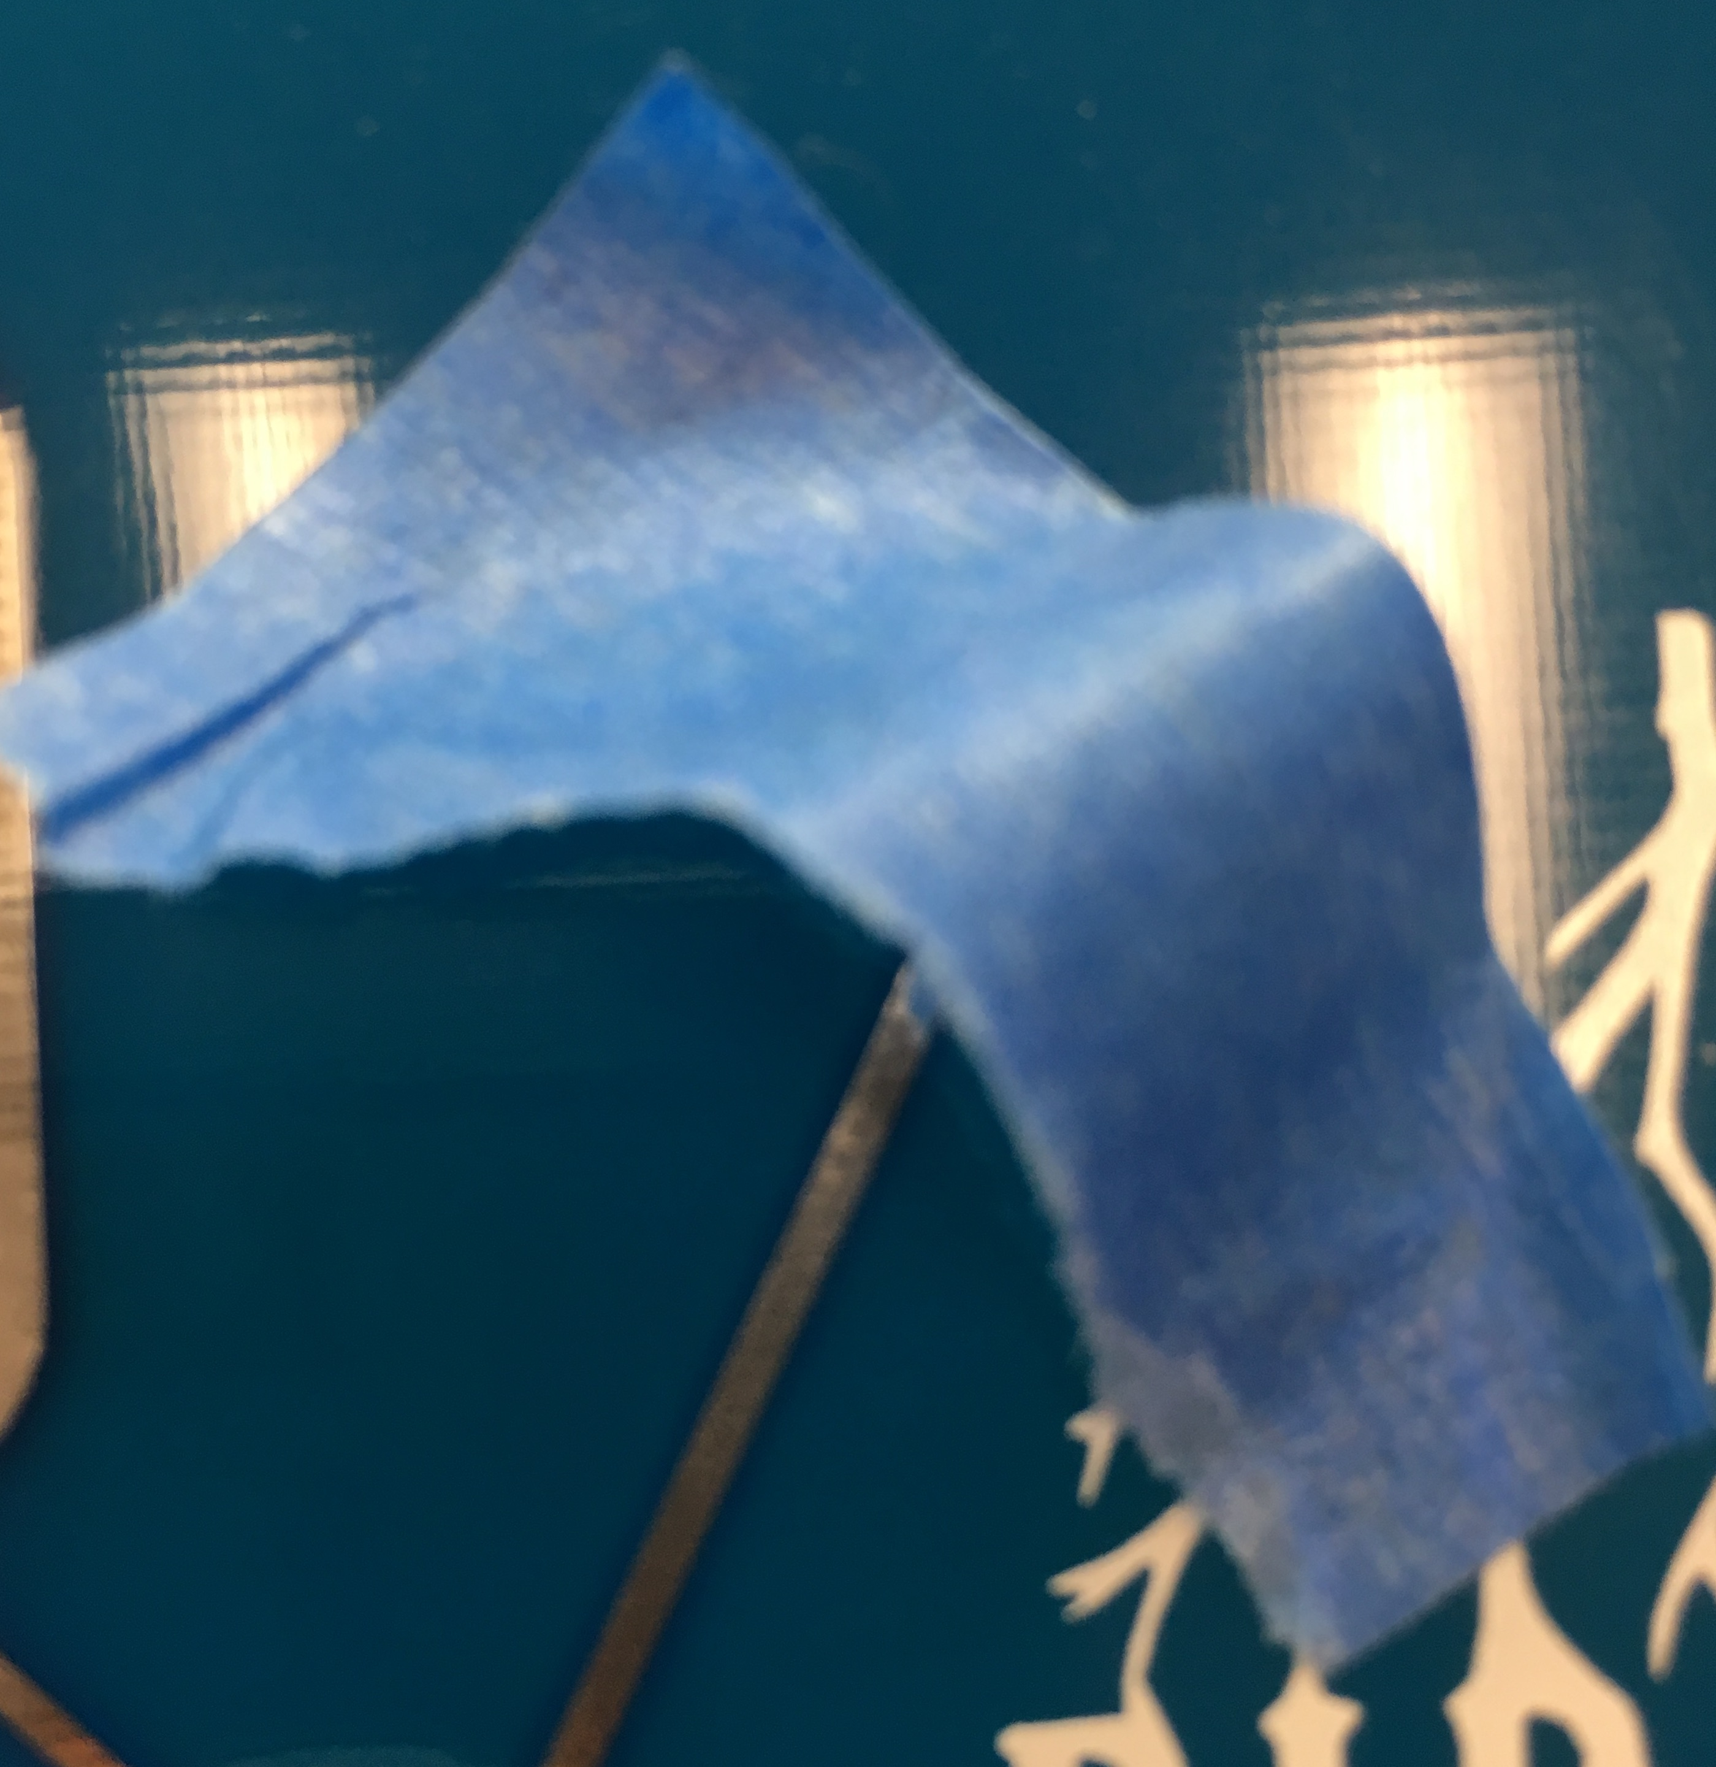From the side with PIRA logo, push the brushes in each board. Tape the brushes from this side to prevent them from falling out. Note-the metal part of the brushes should be at the surface level of the other side.
* Solder the brushes (inner board side). Do this for each board.

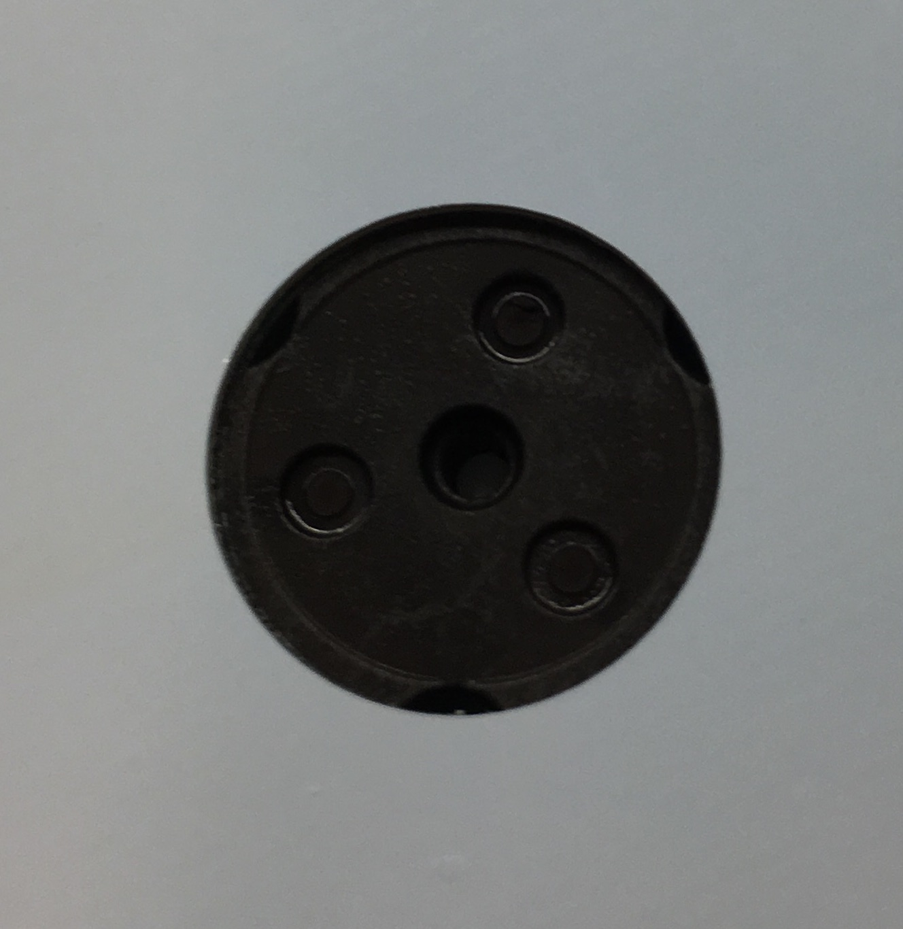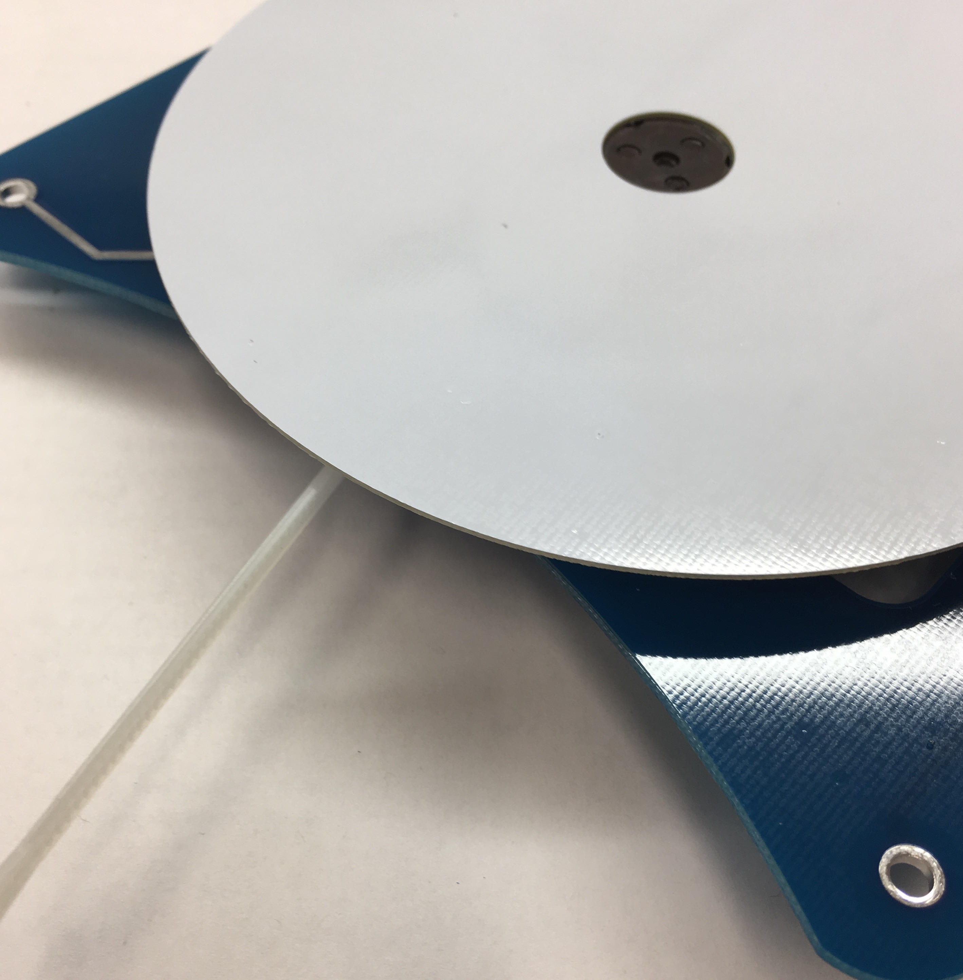

* Peel the paper off the tape on the hub. **Very carefully** place the hub on the disk (pad side towards the hub). Be sure that it is well centered. If it is not, it will cause unwanted vibrations.
* 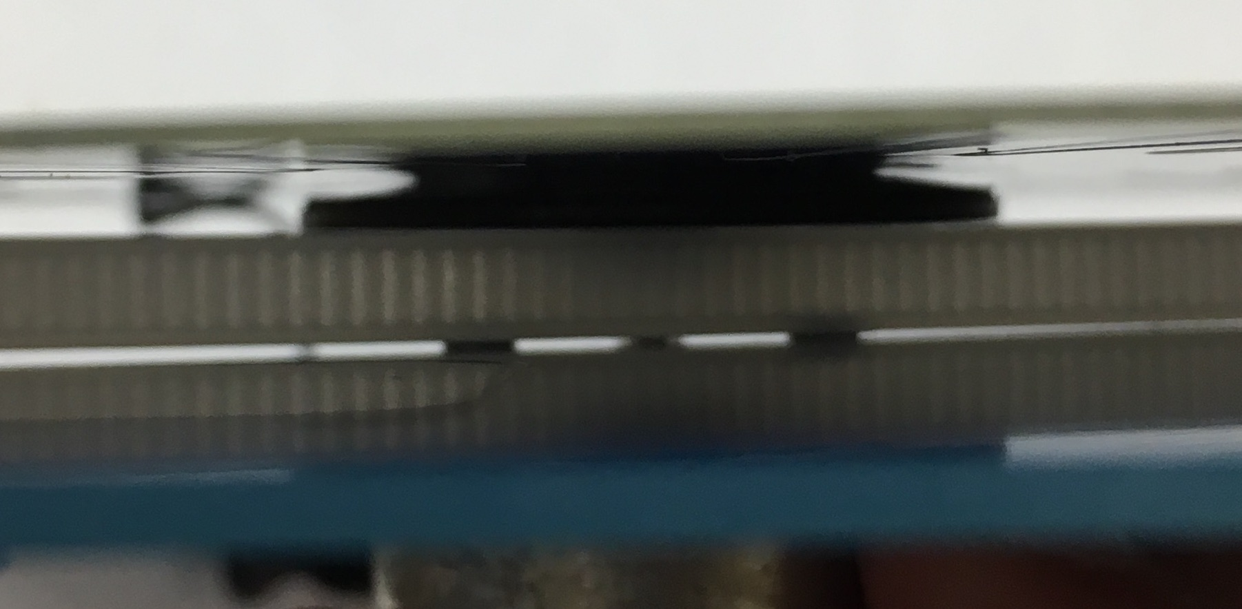Push the hub on the motor shaft. The hub should be the width of a zip tie from the board’s surface. **Note - do not rock the hub as you push it down (it will break)**. Use a small amount of soap if it does not slide on.

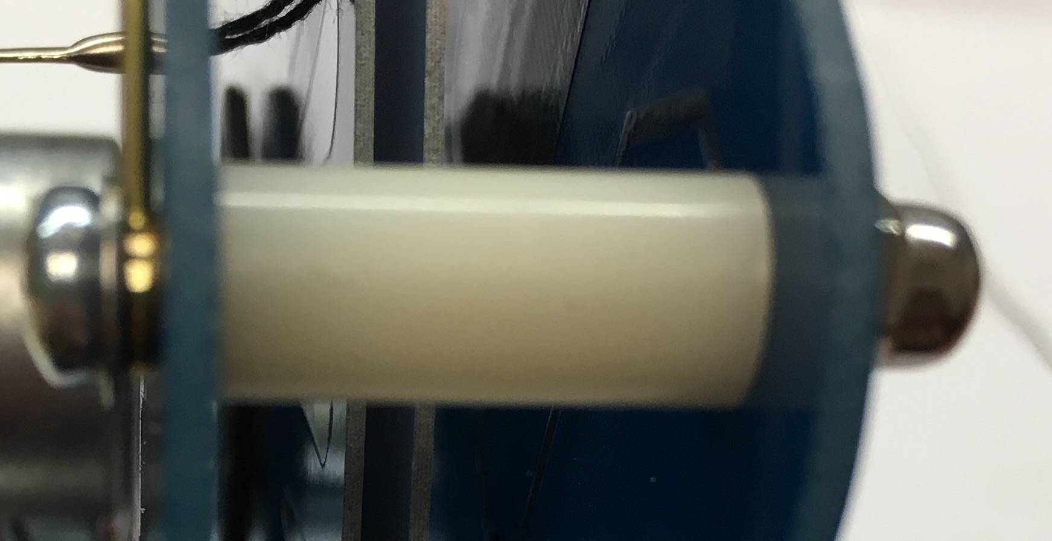

* Place an M3 screw through holes on the bottom of the back board. Push a spacer on the screw and into the corresponding hole of the other board. Screw the dome nut on it and repeat for the other bottom screw.
* Look at the spacing between disks: it should be 1-3 mm, and the disk should not hit the combs when rotated.
* For the top screws place a washer then electrode on the screw, then repeat the process above.

**Wimshurst operation**

Place batteries in the device noting the polarity. Adjust the spark gap to 5-20mm (start small at first). Push the power button and enjoy.

**Hints**: High humidity will cause the device to work poorly. If the device moves or seems unbalanced try to re-center the disk on the hub. Make sure the disks are counter-rotating. If the disk spacing is too large it will not work. To test this, simply push the motors on each side. This will cause the boards to bend and the disks to get closer. Clean the capacitors and disks with ethanol.

**Appendix I**

**Corona Spinner**

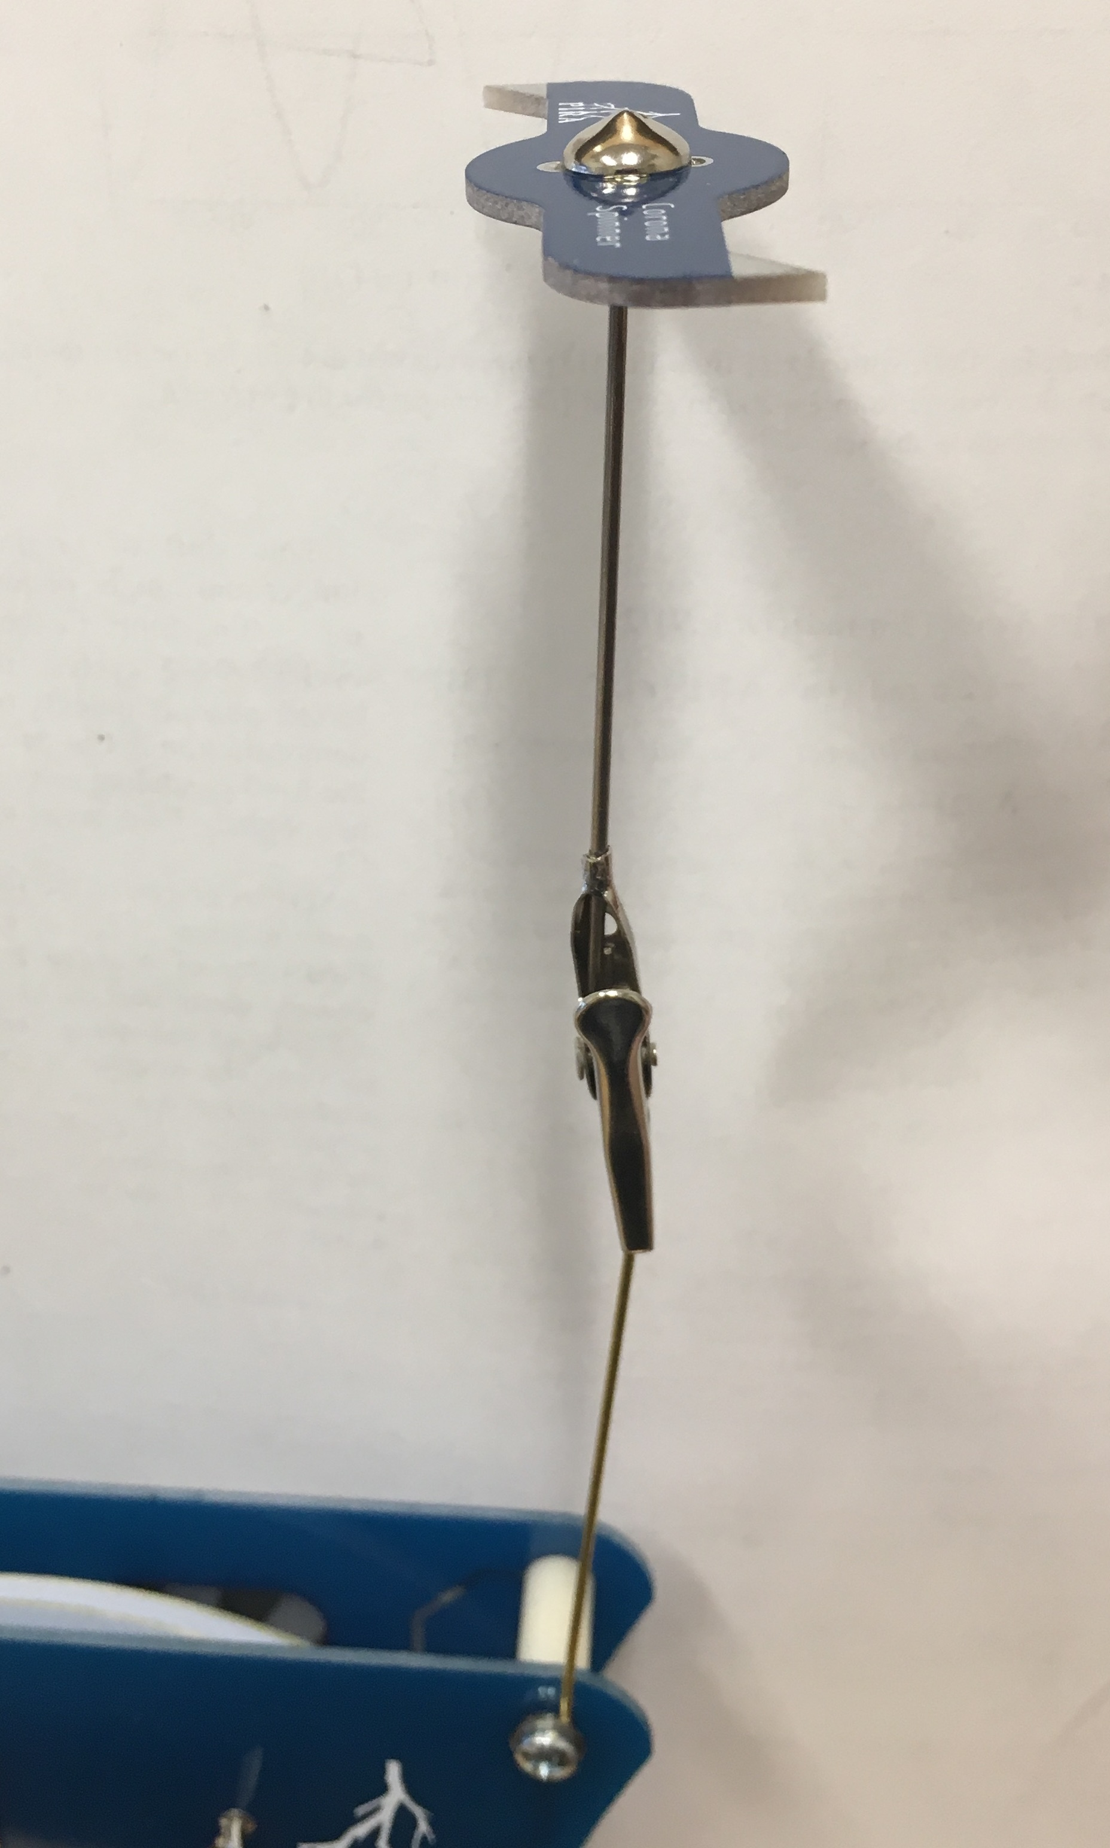

The corona spinner rotates due to the repulsion between the charged spinner and the ionized air. The air is ionized with same charge found on the spinner, leading to a repulsive force between the point and the charged air molecules.

The Corona Spinner kit contains the following components:

* 1 – PCB
* 1 – Metal cone
* 1 – Clip with point
* 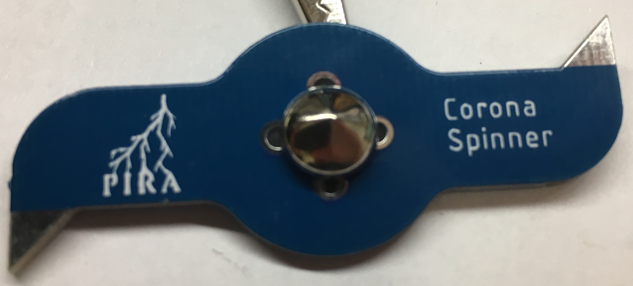Take the cone and place it on the logo side of the PCB.
* Bend the legs to hold it in place. Solder the four points. This might take time as the top, bottom, and cone have a lot of thermal mass.

**Corona Spinner operation**

Move the electrodes far from each other and place the alligator clip on one electrode. With the point straight up, place the corona spinner on it making sure it is balanced. Ground the other electrode by holding it. Turn the Wimshurst on and watch the corona spinner spin.

**Appendix II**

Making your kits for others

Consult the spreadsheet for part vendors. A few parts need to be constructed or modified including: brushes, combs, electrodes, hubs, and battery holders. To make brushes, take the conductive yarn identified in the spreadsheet and fold it over so it is two threads thick. Feed it through the fishing crimp, allowing at least 1’’ on one side. Crimp the bottom (not the side the thread is sticking out) of the barrel. The combs are 90 degree header pins that can be bought with alternating directions or you can do it by hand. Cut the headers to 4 pin sections and trim the top to 1mm above the surface. The bottom pins should be trimmed a little, but it is not necessary. Electrodes are 1mm brass rods that have a brass bead soldered on them. Both of these parts are in the spreadsheet, but the end loop requires a special tool. It can be done by hand but will tax your hands really fast. The one step looper tool or bail looping pliers can be used. Remember that sharp edges are the enemy of high voltage devices like this. The ball bearing holder part of the hubs in the spreadsheet need to be removed and double-sided tape needs to be added. I used a vinyl cutter (cricut) to make the double-sided tape rings (can be cut by hand). The battery holder needs to have the pins bend out and some double-sided foam tape added to the bottom far corner. The tape has to be small enough to not touch the capacitor.

The PCBs can be ordered from China using the gerber zip files on github. It just needs to be uploaded and a color and quantity picked. JLCPCB is very affordable and delivers fast. The overall kit cost is $10-15 depending on the quantity.